Investigation on the Impact of Harmonic Distortion and Reactive Power Consumption on Meter Accuracy

March 17, 2020

# Researchers

The principal investigator (PI) of this proposed project is Yang Weng and his email is [yang.weng@asu.edu.](mailto:yang.weng@asu.edu) The co-PI is Qiushi Cui with the email of [qiushi.cui@asu.edu.](mailto:qiushi.cui@asu.edu)

A new graduate student will be recruited to work on this project.

# SRP Program Managers

Mr. Robert Trask is the project administrators at SRP for this project.

# Period of Performance

The project is expected to start in August 2020. The final reporting shall be at the end of the project in August 2021.

# Introduction

## Understanding Second Generation Solid-State Meter and Its Need

SRP is the highest-ranked electric utility in customer satisfaction with more than 1 million customers in the west region of the USA. Achieving such a great feat is a matter of pride for both SRP as well as its customers. Being a large corporation with such prestigious awards and accolades comes with a huge responsibility towards its consumers. From the perspective of SRP, the robustness, accuracy, durability, as well as the economic cost of using the solid-state meters are important. However, the major factor that plays a crucial role in customer satisfaction is a reliable meter reading that depends on the accuracy of the meter. As the penetration of PV systems and inverter-interfaced loads gets deeper in SRP networks, the harmonic distortion and reactive power consumption issues brought by the power electronics devices play a significant role in SRP’s metering service. If we are not sure about the meter performance with power electronics devices, customers may be charged inaccurately for energy consumption in case of inaccurate measurement. Hence, we need to have a better understanding on the accuracy and dependability of the solid-state meters under the wide implementation of inverter-interfaced devices. **This project fits well into the strategic research identified by the document “Request for Proposals to Conduct Research with SRP”.** **The categories include “data collection”, “enhanced business effectiveness”, and “advanced distribution technologies”, etc.**

The solid-state metering technology was introduced in the 1970s. The use of the solid-state meters began for large commercial users in the 1980s and became the standard in the 1990s. Now widely used, the solid-state meters are a norm in the industry. The reason to replace the Electromechanical meters was the need for more advanced functionality. Since, inaccurate metering and billing by SRP can have a toll on its profit, precision in the measurement of energy consumption in a consistent, and an accurate manner is significant to the operations of SRP. Solid-state electronic meters measure the power consumption using embedded software, storage elements as well as a digital liquid crystal display (LCD), against the use of registers in case of Electromechanical meters to measure the total consumption of power over a period of time. To test these electricity meters, it is imperative to build SRP’s own testbed that is tailored to conduct the test scenarios for SRP’s particular needs. Equipment test manufacturers provide a spectrum of solutions to simplify the testing. For example, the test set from Omicron Inc. not only provides the test signals, but also has inputs for the meter pulses allowing closed-loop testing (as shown in Fig. 1).

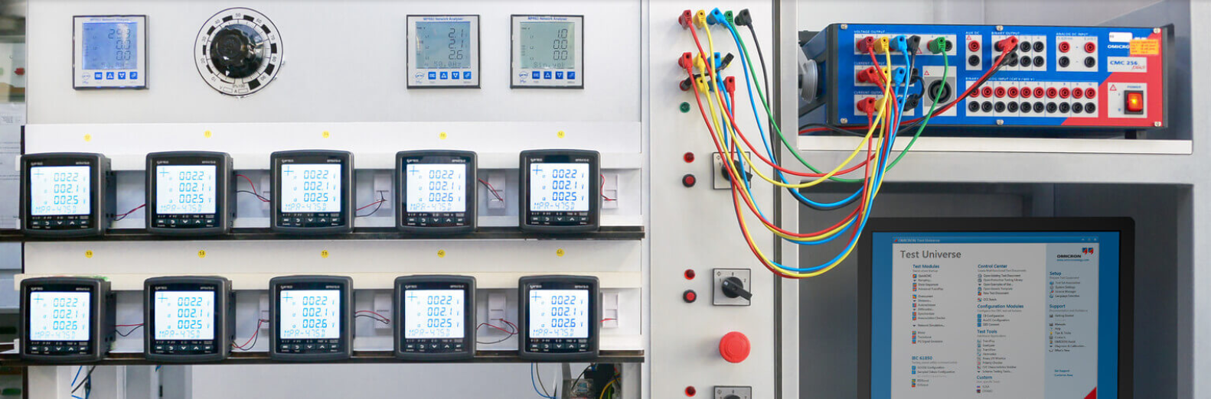

Fig. 1 Measurement equipment testing solution from Omicron

We have not accumulated sufficient knowledge on solid-state meters and the performance of power electronics devices, therefore, it is essential to understand the second generation solid-state meters, along with the impact of power usage as well as that of the environmental factors on the meter reading. This proposal is to help SRP understand meter accuracy under various types of residential load and power system scenarios using the testing chamber in SRP facility. Considering the experience with smart meter experience combined with the technical proficiency of the group on statistical machine learning applications for power systems, the PI is confident that the research can be carried over seamlessly. The following sections explain the issues associated with solid state meters and solutions, experimental setup as well the breakdown of the project objectives in a detailed manner.

## Inaccuracies in Measurement of Solid-State Meter

A study on European watt-hour meters [1], [2] have observed errors in energy usage, up to 500% when smart meters are faced with extremely non-sinusoidal AC waveforms. Hence, it raises questions about whether a very high number of harmonics contained in these waveforms are measured consistently by the electronics in some smart meters. This would not only affect the accuracy of electrical energy measurement but also communicate wrong information on actual energy usage to the control algorithms used in the future Smart Grid, affecting power station operations [3]. In another study, meters exposed to extreme working conditions in the presence of distorted wave- forms, have presented high measurement errors [4].

Hence, it is vital due to the presence of electronic components in a solid-state meter that SRP study the various environmental and power usage impact on the measurement of the meters and understand the second-generation solid meters in a better way.

### Comparison of Measurement for Linear Vs Nonlinear Loads

Recently, there has been an exponential growth in the usage of electronic devices which by nature are nonlinear. This is due to the fact that more sophisticated electronic devices are fitted with a large number of semiconductor elements. Surprisingly, many of these nonlinear devices are energy-conserving devices such as dimmers, energy-efficient motors, and compact fluorescent lights.

Even the majority of household equipment – lighting as well as recreational facilities is equipped with electronic components which leads to the problem of voltage distortion in the distribution net- works. The installation of active filters in the points where disturbing loads are connected is one of the viable solutions to maintain power quality. The active filters inject harmonic power converted from the fundamental component at the point of common coupling, in order to compensate for the current distortion due to the presence of nonlinear loads.

In the study [5], consisting of a set of nonlinear loads composed of personal computers, the measurement of energy registered by the meters increases over 9% when the filter is used, as compared to the case without the use of an active filter. The economic and social impact on the customers should be studied to establish the loss-to-gain ratio.

### Inaccuracy Introduced by Harmonics and Reactive Power

Inaccuracy in solid-state meter also arises due to the presence of a reactive power component. Two major sources of reactive power are as follows:

* Phase difference between the voltage and current waveform, primarily due to the presence of device inductance or capacitance in nonlinear loads.
* Waveform distortion from a nonlinear load, primarily due to harmonic contents.

To evaluate the harmonic distortion, we use total harmonic distortion (THD) of the measured voltage. THD is a common measurement of the level of harmonic distortion present in power systems. THD can be related to either current harmonics or voltage harmonics, and it is defined as the ratio of total harmonics to the value at fundamental frequency times 100%:

$THD_{V}=\frac{\sqrt{\sum_{k=2}^{n}{V_{k}^{2}}}}{V_{1}}∙100\%$,

where $V_{k}$ is the RMS voltage of k-th harmonic, and k = 1 is the fundamental frequency.

The reactive power does not transfer useful energy. Hence it is complicated on how to measure and calculate VAR in the presence of harmonic content. The solid-state meters have shown a wide variation in VAR results when supplied with harmonic energy [6]. The reactive power will be measure by power analyzer. Theoretically, the load current has a phase difference of 90° concerning that of the supply voltage, and it is evaluated by the equation $Q=VIsinθ$, where $θ$ is the phase of voltage relative to current.

Due to the inaccuracy introduced by harmonics and reactive power, there is a need to analyze the nonlinear loads in the presence of harmonic energy and understand the relationships between the actual power consumption and the meter reading as well as considering the VAR components of the energy consumption of their customers, for the purpose of fair commerce.

### Environmental Impact on Solid-State Meter

Extreme weather such as extra heat occurs annually in Arizona. The electronic components of a solid-state meter are impacted by environmental conditions, which play a key role in the longevity and reliability of its components. Hence, there is a need for SRP to understand the solid-state meters under different weather conditions using a functional analysis of the metering devices. Associated experiments are necessary.

# Reference Standard and Testbed

The proposed meter testing follows the reference standard with traceability to National Institute of Standards and Technology (NIST). The International Vocabulary of Basic and General Terms-available from the NIST-defines traceability as "the property of the result of a measurement or the value of a standard whereby it can be related to stated references, usually national or international standards, through an unbroken chain of comparisons all having stated uncertainties." [7] A meter manufacturer publishing specifications that reference IEC or ANSI standards provides “consumer assurance” that the meter has undergone rigorous performance tests. Furthermore, both meter type tests and acceptance/conformity tests involve test equipment whose voltage and current supplies generate accurate real world signal phenomena. Type tests are performed by the meter manufacturer on one prototype, or a sample number of meters of the same type, to ensure compliance with all aspects of the standard. However, the utility is responsible for acceptance/conformity testing on a sample size determined by the utility based on the quantity purchased. Tests may differ where legal requirements between states and countries influence test procedures used by the utility.

IEC 61036 defines the accuracy limits for each class of meter. Furthermore, it lists the influencing quantities that the meter must be subjected to at specified reference voltages and currents. Harmonics influences and associated test limits are divided into the following three tests:

* Half wave rectification (dc and even harmonics)
* Phase fired control (odd harmonics)
* Burst control (sub-harmonics).

In each of these three tests, the limit of error is 3.0% for Class 1 meters. A further accuracy requirement is placed on the meter with regard to the correct measurement of power, with a 5th harmonic component, of magnitude 0.5 $I_{max}$. The allowable variation in percentage error is 0.8%. IEC 61036 also provides guidance on test equipment connection; specific waveforms used to generate the required harmonics; and direction on connecting a reference meter used as a comparison device.

Smart meters are designed to be read in several ways. Some transmit information to readers of some sort (RF, Ethernet, USB, signal on power line transmission, etc.). They can be read by eye from the digital readout. There is also an infrared pulse port for testing and readout purposes that is used in this procedure. Each pulse registers an energy value as specified by its Kh factor (a constant ‘Kh’ number of watt-hours per pulse). To automate this test platform, we plan to use optical detectors to sense the infrared pulses. The pulses are recorded and time-stamped via software. The electrical energy used is the total number of pulses for a test time multiplied by the Kh factor. Each smart meter reading is then compared to the measurement from a separately calibrated power analyzer.

We will utilize power analyzer as the main calibration equipment in our harmonics and power consumption analysis testbed. Tests will be conducted to monitor multiple phase line voltages and currents, digitize the signals and calculate the various parameters. This is much like the inner working of the smart meters but recording at a much higher rate of about a mega-sample per second. The power analyzer will be calibrated using a custom-built NIST sampling wattmeter, an instrument that has been upgraded to provide calibration capability for power with higher harmonic components. These calibration measurements are based on techniques reported previously [8]. For a general test, the power analyzer will be checked on its high current input elements, 120 V at 60 Hz and at 5 A using a pure sine wave at phases 0°, +60°, -60°.

Besides, the testbed controls the following parameters:

1. Controlled Parameters: Environmental conditions in the testing chamber such as atmospheric temperature, humidity; the operating conditions of all kinds of home appliances, including heaters, microwave, dishwashers, washers, dryers, lights, ventilation systems, air conditioning (HVAC), rooftop units (RTUs), and variable refrigerant flow (VRF), etc.
2. Uncontrolled Parameters/Independent Parameters: Parameters controlled by the energy usage trend of customers such as Waveform Distortion, Harmonics, Reactive Power, as well as distributed energy resources.

# Project Objectives

The principal objectives of the proposed project are:

1. Review of the latest literature on the accuracy of performance for solid-state metering systems and the impact of environmental and load changes on the meters.
2. Setup the testbed according to the reference standard with traceability to NIST.
3. Physical experiments on the meters in SRP facilities, assisted with numerical experiments.
4. Conduct result analytics.
5. Final report to evaluate the impact of power usage and environment factors on the solid-state meters.

# Project Tasks and Organization

The project tasks are enumerated as per the objectives above. The project organization is shown in Figure 1.

|  |  |  |  |  |  |  |  |  |  |  |  |  |
| --- | --- | --- | --- | --- | --- | --- | --- | --- | --- | --- | --- | --- |
| *Tasks* | *Project month* | | | | | | | | | | | |
| 1 | 2 | 3 | 4 | 5 | 6 | 7 | 8 | 9 | 10 | 11 | 12 |
| 1. Review of the latest literature |  | ** |  |  |  |  |  |  |  |  |  |  |
| 2. Setup the testbed |  |  |  |  |  |  |  |  |  |  |  |  |
| 3. Physical experiments |  |  |  |  |  |  |  |  |  |  |  |  |
| 4. Conduct result analytics |  |  |  |  |  |  |  |  |  |  |  |  |
| 5. Documentation |  |  |  |  |  |  | * |  |  |  |  | * |

* Expected main reporting

** Monthly meetings are planned with SRP to assure that the project is on track

**Figure 1:** Research project schedule by tasks

### The project tasks are discussed below.

Task 1: Review of the latest literature on the accuracy of performance for solid-state metering systems and the impact on the systems using test cases.

The ASU team will review literature and standards using the online indexed databases for the past ten years. A survey report will be submitted to SRP on the examination of the accuracy of solid-state meters and challenges in using those meters.

Task 2: Setup the testbed according to the reference standard with traceability to NIST.

We will build a testbed that includes multiple smart meters, infrared pulse interfacing with the meters, power analyzer, and various load. The following test procedures will be applied [9, 10]:

1. We will obtain select power appliances for form different setups of a house to mimic the realistic situations in homes at SRP territory. For example, Fig. 2. shows our power lab with diversified appliances. We will also purchase other appliances, such as condensers and lights to enrich the targeting devices for comparison.

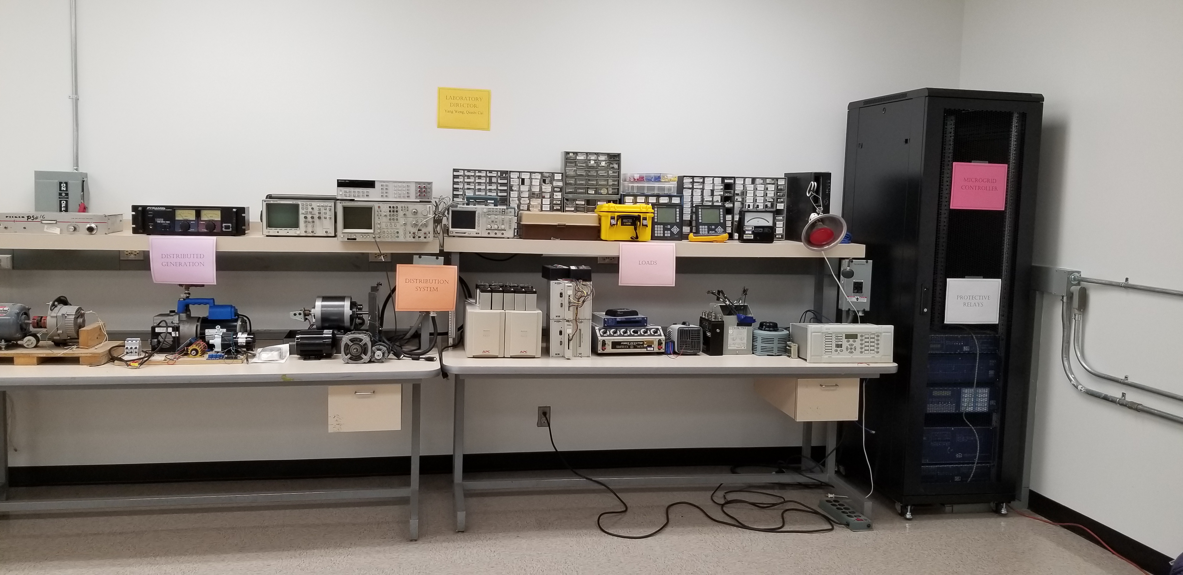

Fig 2. PI’s Lab: different loads with different harmonics and reactive power consumptions

1. Then, we will create comprehensive scenarios with SRP engineers with different level of harmonics and reactive power consumptions. For example, the following is the lightboard layout and data paths [10].

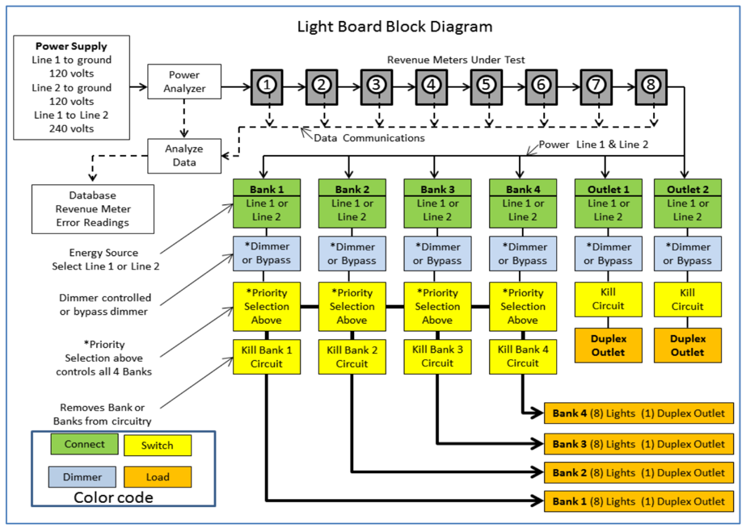

Fig.3. Lightboard layout and data paths

1. 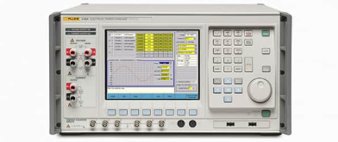Our lab has existing power analyzer, so we will use our power analyzer for initial test. Briefly described, the power analyzer monitors multiple phase line voltages and currents, digitizing the signals and calculating the various parameters, much like the inner working of the smart meters, but recording at a much higher rate of about a mega-sample per second. In the meanwhile, we will also purchase additional power calibrator, e.g., compare if two different power analyzers will give us the same results for reference. If the SRP chamber has these devices, we will also use them.

Fig 4. 6105A, 6100B Electrical Power Quality Calibrator from Fluke Inc.

1. We will put the appliances onto the testing bench, e.g., the picture below, or the SRP chamber. We will use three different measurement devices to measure. These measurement devices are (1) meters from SRP, (2) existing power analyzer at the PI’s lab, and (3) the newly purchased power analyzer or the power analyzer form SRP.

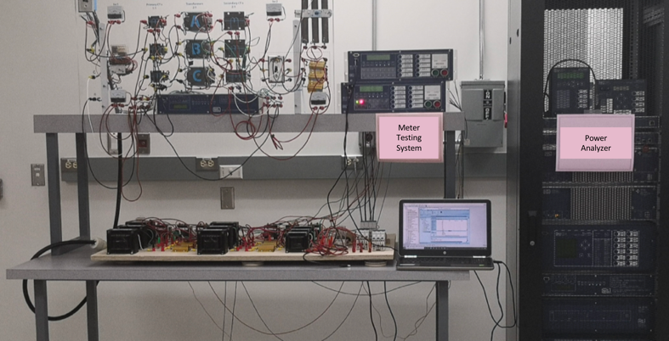

Fig 5. PI’s Lab: meter testing bench

Task 3: Physical experiments on the meters in SRP facilities, assisted with numerical experiments.

The experiment data and their analytics rely on comprehensive comparison and engineering study. The flexible testing algorithm utilizes big data and statistics techniques to estimate the baseline and the consumption calibration between the actual consumption and readings. Different power system scenarios will be taken into consideration. In the end, we will conduct result analysis.

1. We will measure the active power measurements, reactive power measurements from the three devices and also the readings of harmonics on the power analyzer. We will change the room temperature, device combination, and also the power consumptions at different devices to understand obtain data from the three measurement devices.
2. We will test SRP meter with different ages.
3. We will obtain the data and analyze the reasons on why there is incorrect active power consumption, due to misaligned current and voltages.
4. We will use the data and the meter manual to understand the reasons of errors in SRP meters, e.g., from formulas, tables, data analytics.

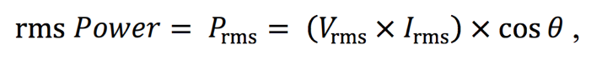

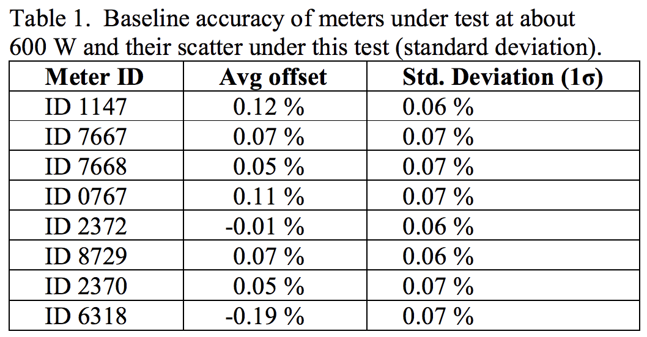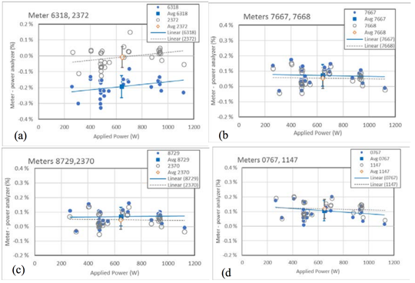

For example, the actual testbed spiked waveforms contained even higher harmonic frequencies, e.g., pictures below, can contribute to the reading uncertainty.

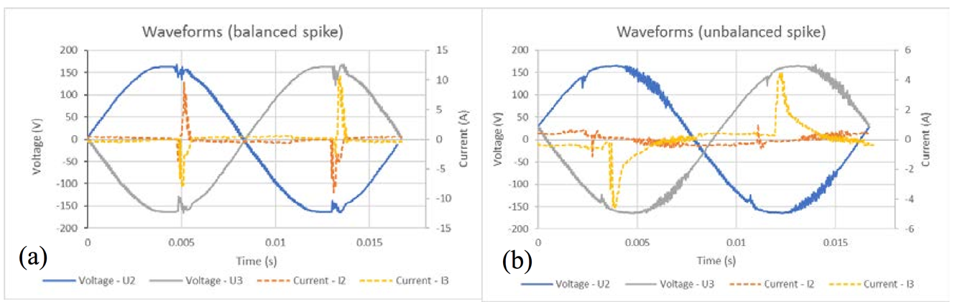

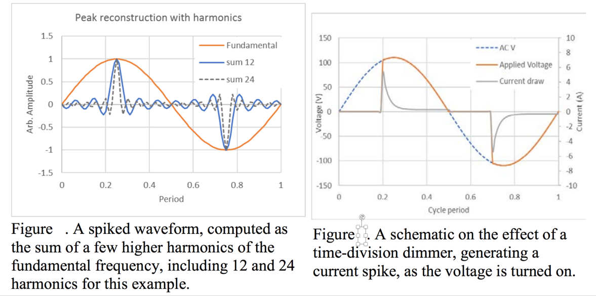

Task 4: Conduct result analytics.

Results will be extensively investigated to evaluate the impact of power electronics devices on meter readings. The impact of harmonics and reactive power consumption will be quantified and enumerated under different operating conditions. Additional test variations will involve adding long lengths of cable to simulate the added resistance and inductance from typical lengths of house wiring. Plus, different styles of light bulbs, different dimmer manufacturers, and different HVAC products can be tested. Faster measurement electronics to measure the voltage and current of the distorted waveforms at higher frequencies will be needed.

1. We will show SRP the reason for meter error, e.g., how the misaligned current and voltage is going to negative impact on active power consumption and reactive power consumption, how the harmonics impact the meter measurements due to spikes, etc.
2. We will provide recommendations to SRP on recalibration of its meters based on a comprehensive documentation.

Task 5: Final report to evaluate the impact of power usage and environmental factors on the solid-state meter reading.

A comprehensive final report will be prepared. The final report summarizes the results of the benefits vs drawbacks of being able to analyze and monitor the solid-state meter reading and the impact on the reading due to the trend of user behaviors. It will also enable data analytics for SRP to demonstrate the test cases examining the accuracy of solid-state meters.

# Significance of the Work

ASU will prepare short monthly status reports and a detailed final report at the end of the project. A draft final report will be submitted for comments and will be discussed in a review meeting. The updated report will be presented within a month after the meetings. ASU will organize at least two review meetings with SRP. This will assure that SRP can directly review progress and propose remedial actions if needed. It is expected that SRP will use the obtained results to evaluate the impact of power usage and environment on the solid-state meter reading. It is also expected that SRP can use the analytics tool in this project to analyze and monitor the solid-state meter reading and the impact on the reading due to the trend of user behaviors. From an educational point of view, the students performing the study will gain valuable practical experience. This student will be ready to join a utility team to perform quality engineering work. We will add well-trained power engineers to the utility market.

# Project Budget

The table below shows the project budget.

|  |  |
| --- | --- |
|  |  |
| Principal investigator support (Prof. Yang Weng) | $5,000 |
| Graduate researcher support* | $49,500 |
| Subtotal | $54,500 |
| Administrative Overhead (10%) | $5,450 |
| *Total requested* | $59,950 |

*Includes tuition and fringe benefits

# References

1. Frank Leferink, Cees Keyer, and Anton Melentjev. “Runaway energy meters due to con- ducted electromagnetic interference”. In: *2016 International Symposium on Electromagnetic Compatibility-EMC EUROPE*. IEEE. 2016, pp. 172–175.
2. Frank Leferink, Cees Keyer, and Anton Melentjev. “Static energy meter errors caused by conducted electromagnetic interference”. In: *IEEE electromagnetic compatibility magazine* 5.4 (2016), pp. 49–55.
3. Richard Steiner et al. “ANIST Testbed for Examining the Accuracy of Smart Meters Under High Harmonic Waveform Loads”. In: *2018 Conference on Precision Electromagnetic Mea- surements (CPEM 2018)*. IEEE. 2018, pp. 1–2.
4. R Quijano Cetina, Andrew J Roscoe, and PS Wright. “A review of electrical metering accu- racy standards in the context of dynamic power quality conditions of the grid”. In: *2017 52nd International Universities Power Engineering Conference (UPEC)*. IEEE. 2017, pp. 1–5.
5. Alfredo Ortiz et al. “Evaluation of energy meters’ accuracy based on a power quality test platform”. In: *Electric Power components and systems* 35.2 (2007), pp. 221–237.
6. Shannon Edwards, Dave Bobick, and Steven Weinzierl. “Impact of harmonic current on en- ergy meter calibration”. In: *IEEE 2011 EnergyTech*. IEEE. 2011, pp. 1–6.
7. NIST Traceability Ensures Power-Meter Accuracy, <https://www.laserfocusworld.com/test-measurement/test-measurement/article/16548411/nist-traceability-ensures-powermeter-accuracy>
8. Stenbakken G N, Dolev A (1992), High-accuracy sampling wattmeter. IEEE Trans. on Instrum. and Meas., 41(6):974–978. <https://doi.org/10.1109/19.199445>
9. Ramboz, John D., and Rita C. McAuliff. "A calibration service for wattmeters and watthour meters." National Bureau of Standards technical note 1179 (1983).
10. Richard Steiner, Michael Farrell, Shannon Edwards, Joni Ford, Sumaiyah Sarwat, Thomas Nelson, A NIST Testbed for Examining the Accuracy of Smart Meters under High Harmonic Waveform Loads, <https://doi.org/10.6028/NIST.IR.8248>, National Institute of Standards and Technology.

**Yang Weng**

Assistant Professor

School for Electrical, Computer and Energy Engineering

Arizona State University, 551 E Tyler Mall, ERC 563, Tempe, AZ 85281

Phone: (480) 965-8202; E-mail: [yang.weng@asu.edu](mailto:yang.weng@asu.edu)

**Education and Training**

Stanford University, Stanford, Post-Doctoral Fellow, 2014 - 2016

Carnegie Mellon University, Pennsylvania, Electrical Computer Engineering, Ph.D., 2014

Carnegie Mellon University, Pennsylvania, Machine Learning, M.S., 2014

Carnegie Mellon University, Pennsylvania, Electrical Computer Engineering, M.S., 2013

**Professional Experience**

Assistant Professor, School of Electrical, Computer and Energy Engineering, 2017-Now

Task Force Chair, IEEE PES Subcommittee-Big Data & Analytics for Power Systems, 2017-Now

**Synergistic Activities**

* Served as PI or Co-PI for ~$**10M** in research and educational projects funded by NSF, DOE, EPRI, PSERC, SRP, and DLC, etc.
* Teaching undergraduate and graduate courses on power system transmission and distribution, demand response, machine learning for power systems, machine learning for smart grid, circuits, and other subjects
* **Chair**, IEEE Phoenix Chapter - Conference Division, 2018-Now
* **Co-Chair**, IEEE North American Power Symposium, 2020
* **Tutorial Chair**, IEEE International Conference on Communications, Control, and Computing Technologies for Smart Grids (SmartGridComm), 2020
* Supervised 2 postdocs, 10 PhD, 10 MS, and 4 honors theses (as of Mar 2020)

**Honors**

* **Outstanding IEEE Young Professional Award**, IEEE Phoenix Section, Phoenix, Mar 2020
* **Outstanding Faculty Mentor Award**, Graduate School, ASU, Feb 2020
* **IEEE Foundation Recognition**, for Service in PES Scholarship Plus, Dec 2019
* Nomination for the **Outstanding Taskforce**, IEEE Power Energy Society (PES), Recommended by IEEE PES Big Data & Analytics Subcommittee, Dec 2019
* **Best Paper Award**, IEEE Sustainable Power & Energy Conference, Beijing, Nov 2019
* **Best Paper Award** (Ranking 1st out of 203 Participates), North American Power Symposium, Wichita, KS, Oct 2019
* **2nd Place in accuracy and 1st Place in speed** of the RTE International Competition on “Learning to Run a Power Network”, TeamName: Learning_RL, Method: Reinforcement Learning (Stationary MDP for Convergence + Action Space Pruning + Reduce State Space for Q-Learning), Paris, France, 2019
* **Winner Award of Chunhui Cup** in the International Competition on Innovation and Entrepreneurship, Area: Renewable Integration, Guangzhou, China 2018
* **Best Paper Award**, IEEE Conference on Energy Internet and Energy System Integration, Beijing, China 2017
* **Best Paper Award** (**Ranking First**), IEEE International Conference on Probabilistic Methods Applied to Power Systems, Beijing, China 2016
* **Fellowship**, TomKat Postdoctoral Fellow, Stanford TomKat Center for Sustainable Energy, Stanford University, Stanford, CA 2015
* **Best Papers**, IEEE Power and Energy Society General Meeting, National Harbor, MD 2014
* **Best Poster**/Position Paper Finalist, NSF Young Professional Workshop on Exploring New Frontiers in Cyber-Physical Systems, Washington, D.C., USA, 2014
* **Ranking First** in all Papers at the IEEE International Conference on Smart Grid Communications, Vancouver, Canada 2013
* **ABB Fellowship** in recognition of work on Power System State Estimation, ABB Inc., USA 2013
* **Best Paper Award** at the IEEE International Conference on Smart Grid Communications, Taiwan, 2012
* **Dean’s Graduate Fellowship**, The Nicholas Minnici, Carnegie Mellon University, USA 2010

# Other Activities

* 80 Invited Talks and 90+ Webinar Chairs
* Patent: Effective Feature Set Based High Impedance Fault Detector, Invention ID: M19-256P, Tech Id: M19-256P

# Key Related Publications (Google Scholar h-index = 16 as of Mar 2020) (Total Publication: 70+, Journal Publication: 30+, Conference Publication: 40+)

J. Yu, Y. Weng, and R. Rajagopal, “Data-Driven Customer Baselining and Targeting for Demand Side Management Programs”, IEEE Transactions on Smart Grid.

G. Xie, X. Chen, and Y. Weng, “An Integrated Gaussian Process Modeling Framework for Residential Load Prediction”, IEEE Transactions on Power Systems, 2018.

P. Li, B. Zhang, Y. Weng and R. Rajagopal, “A Sparse Linear Model and Significance Test for Individual Consumption Prediction,” IEEE Transactions on Power Systems, vol. 32, no. 6, pp. 4489-4500, Nov. 2017.

Y. Liao, Y. Weng, and R. Rajagopal, “Urban MV and LV Distribution Grid Topology Estimation via Group Lasso”, IEEE Transactions on Power Systems, 2018.

Y. Weng, Y. Liao and R. Rajagopal, “Distributed Energy Resources Topology Identification via Graphical Modeling,” in IEEE Tran. on Power Systems, vol. 32, no. 4, pp. 2682-2694, 2017.

Q. Cui, Y. Weng, and C. Tan, “Electric Vehicle Charging Station Placement Method for Urban Areas”, IEEE Transactions on Smart Grid, 2019

J. Yu, Y. Weng, and R. Rajagopal, “PaToPaEM: A Data-Driven Parameter and Topology Joint Estimation Framework for Time Varying System in Distribution Grids”, IEEE Transactions on Power Systems, 2018.

Y. Weng, R. Negi, and M. Ilic, “Probabilistic Joint State Estimation for Operational Planning”, IEEE Transactions on Smart Grid, 2017.